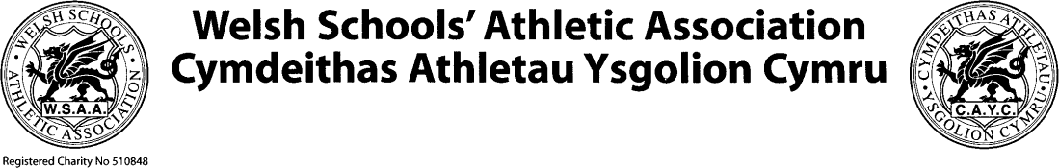

Welsh Schools’ Athletics Association/Cymdeithas Athletau Ysgolion Cymru Welsh Athletics U20 International – Venue TBC (Wales)
Saturday 26th August 2023

Overview: | The overall objective of the Welsh Athletics and Welsh Schools’ Athletics Association (WSAA) International Competitions Programme is to support athletes to experience high level competition and aspire to perform at their best against athletes across the UK and abroad. As part of that strategy, Welsh Athletics and Welsh Schools’ Athletics Association are committed to providing domestic and international competition opportunities to  developing and aspirational Welsh athletes.
Athlete Eligibility: | To be considered for a Welsh Schools Team pupils must be in school/college in Wales.  Pupils in school/college years 12-14 will be given priority for selection. At the discretion of the selection panel pupils in school years 10 and 11 may be considered for the team.
Competition format and Age Groups | This fixture provides an U20 age group competition for Welsh Schools’ Athletics Association pupils against home countries teams and a Welsh Athletics team.  1 pupil per gender in the following events will be selected: U20 Men:  100m, Ambulant 100m, 200m, 400m, 800m, 1500m, 3000m, 5000 walk,  110m Hurdles, 400m Hurdles, Long Jump, Ambulant Long Jump, High Jump, Pole Vault, Triple Jump Shot Put, Discus, Javelin, 4 x 100m Relay, 4 x 400m Mixed Relay (2 male athletes)  U20 Women:  100m, Ambulant 100m, 200m, 400m, 800m, 1500m, 3000m, 5000 walk,  110m Hurdles, 400m Hurdles, Long Jump, Ambulant long Jump, High Jump, Pole Vault, Triple Jump, Shot Put, Discus, Javelin, 4 x 100m Relay, 4 x 400m Mixed Relay (2 male athletes)  There will be an opportunity in both genders for integrated throws and seated throws for guest Para Athletes by invitation.
Selection Date: | The selection panel will meet on Wednesday 17th July 2022
Selection Panel: | The International Selection Panel will comprise of:  - WSAA International secretary  - WSAA Chair  - 1 representative from each of the eight school districts

 | - 2 Welsh Athletics representative (including the Athletics Para Pathway lead)
Selection Basis: | Selections will be based on the following:  - Pupils must have achieved the WSAA U20 international competition standard outlined below between January 1st and July 16th 2023. Performances must be ratified on the power of 10 rankings website.  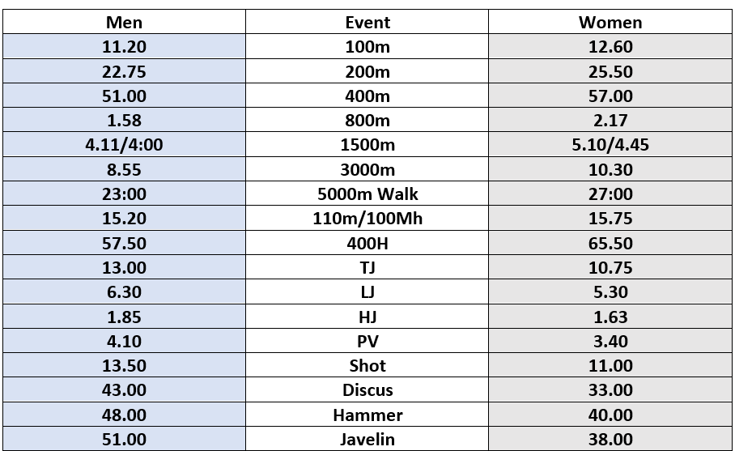  - Pupils are encouraged to attend the Welsh Schools’ Athletics Association Track and Field Championships held on Saturday July 1st. A commitment to competing for your school and district will be taken into consideration by the selection panel.  - Para athletes will be selected based on Raza Points and 2022 power of 10 rankings. Para athletes must have an IPC or UKA classification.  Please note there is no obligation for the panel to fill all available positions
Pupil Notification: | Pupils will be notified of their selection within 24 hours of the Selection  Meeting.
Appeals Process: | There shall be no right of appeal to the selection of the Welsh team made by  the Panel.
De-Selection Process: | De-selection of a pupil may occur following:  - Failure to achieve the standard fitness testing protocols  - Failure to adhere to the Welsh Athletics and Welsh Schools’ Athletics Association athlete code of conduct  If any pupil sustains an injury following acceptance of their position on the team, they are required to inform the team contacts below immediately.

Clean Sport: | Welsh Athletics and the Welsh Schools’ Athletics Association are fully committed in supporting the UKAD (United Kingdom Anti-Doping) Clean Sport Programme - www.ukad.org.uk/athletes  We will continue to deliver athlete, coach and staff training to sure a high level of knowledge and understanding to protect our sport.
Equality Statement: | Welsh Athletics and the Welsh Schools’ Athletics Association are committed to offering equal opportunities to all athletes in Wales. Any pupil who goes to school in Wales is eligible to be selected and will be considered as part of the selection process, providing they have achieved all that is laid out within this selection policy. Welsh Athletics will not discriminate in the selection of any  individual on the basis of any protected characteristic.
Amendment: | Welsh Athletics and the Welsh Schools’ Athletics Association reserve the right to amend this Selection Policy at its sole discretion and will make any amended version publicly available (including the date on which the  amendment was made) at www.welshathletics.org
Contact: | Team administrator & logistics bethan.davies@welshathletics.org Team selection & composition rhys.williams@welshathletics.org Welsh Athletics Para Pathway Lead neil.taylor@welshathletics.org  Lead Team Manager zaneiswales@hotmail.com

